**Assessment – 4**

|  |  |
| --- | --- |
| **NAME** | GRANDHI SAIRAM |
| **ROLL NO** | 21T95A0508 |
| **COLLEGE NAME** | GIET ENGINEERING COLLEGE |
| **EMAIL** | sairamgrandhi1@gmail.com |

1. **What is the purpose of the activation function in a neural network, and what are some commonly used activation functions?**

Ans: The activation function in a neural network serves two main purposes:

1. **Introducing non-linearity:** Activation functions introduce non-linearity into the output of each neuron. This non-linearity is crucial for enabling neural networks to learn complex patterns in data. Without non-linear activation functions, a neural network would essentially reduce to a linear model, severely limiting its expressive power.
2. **Normalization and scaling:** Activation functions can help normalize the output of neurons, ensuring that the values fall within a certain range. This can aid in stabilizing the training process and preventing issues like exploding or vanishing gradients.

Some commonly used activation functions in neural networks include:

* **Sigmoid**: The sigmoid function squashes the input into the range (0, 1). It's often used in the output layer of binary classification problems.
* **Hyperbolic tangent (tanh):** Similar to the sigmoid function, but it squashes the input into the range (-1, 1).
* **Rectified Linear Unit (ReLU):** ReLU sets all negative values in the input to zero, while leaving positive values unchanged. It's one of the most widely used activation functions in deep learning due to its simplicity and effectiveness.
* **Leaky ReLU:** Leaky ReLU is similar to ReLU, but instead of setting negative values to zero, it allows a small, non-zero gradient to pass through. This helps mitigate the "dying ReLU" problem where neurons can get stuck in a state of inactivity.
* **Exponential Linear Unit (ELU):** ELU is another variation of ReLU that allows negative values but with smoother behavior. It has a saturation range which can help with the vanishing gradient problem.

**2.Explain the concept of gradient descent and how it is used to optimize the parameters of a neural network during training?**

**Ans:** Gradient descent is a fundamental optimization algorithm used to minimize the loss function and update the parameters (weights and biases) of a neural network during training. The goal of training a neural network is to adjust its parameters such that it can accurately map input data to the corresponding output labels.

Here's how gradient descent works in the context of neural network training:

**1. Initialization:** Initially, the weights and biases of the neural network are randomly initialized

**2. Forward Pass**: During the forward pass, input data is fed into the network, and the network computes the output predictions by passing the data through each layer, applying activation functions, and computing the final output.

**3. Loss Calculation:** Once the predictions are obtained, a loss function is used to measure the discrepancy between the predicted output and the actual output (ground truth). Common loss functions include mean squared error (MSE) for regression tasks and cross-entropy loss for classification tasks.

**4. Backward Pass (Backpropagation):** After computing the loss, the gradient of the loss function with respect to each parameter (weight and bias) in the network is computed using a technique called backpropagation. Backpropagation efficiently calculates the gradient by applying the chain rule of calculus recursively from the output layer to the input layer.

**5. Gradient Descent Update**: Once the gradients are computed, the parameters of the network are updated in the opposite direction of the gradient to minimize the loss function. This update is performed iteratively for a predefined number of epochs or until convergence.

**6. Repeat**: Steps 2-5 are repeated for each batch of training data until all the data has been used for training (one epoch). This process may be repeated for multiple epochs until the network converges to a satisfactory solution**.**

**3.** **How does backpropagation calculate the gradients of the loss function with respect to the parameters of a neural network?**

Backpropagation calculates the gradients of the loss function with respect to the parameters of a neural network using the chain rule of calculus. It works in two phases:

1. **Forward Pass:** During the forward pass, input data is fed into the network, and the network computes the output predictions by passing the data through each layer, applying activation functions, and computing the final output. The intermediate activations and outputs of each layer are stored.
2. **Backward Pass (Backpropagation):** After computing the loss, the gradient of the loss function with respect to the output of the network is computed. Then, using the chain rule, gradients are recursively propagated backward through the network to compute the gradients of the loss function with respect to each parameter (weights and biases) in the network.

Specifically, for each layer, the gradients are computed as follows:

* Compute the gradient of the loss function with respect to the output of the current layer.
* Use this gradient to compute the gradient of the loss function with respect to the weights and biases of the current layer.
* Propagate this gradient backward to compute the gradients of the loss function with respect to the inputs of the current layer.
* Repeat this process for each layer until the gradients with respect to all parameters are computed.
* By applying the chain rule iteratively through the layers of the network, backpropagation efficiently calculates the gradients of the loss function with respect to all parameters, enabling gradient-based optimization algorithms like gradient descent to update the parameters and minimize the loss.

**4. Describe the architecture of a convolutional neural network (CNN) and how it differs from a fully connected neural network.?**

**Ans:**A Convolutional Neural Network (CNN) is a type of neural network architecture designed specifically for processing structured grid-like data, such as images. CNNs are particularly effective for tasks like image classification, object detection, and image segmentation. Here's an overview of the architecture of a CNN and how it differs from a fully connected neural network (FCNN):

Architecture of a Convolutional Neural Network (CNN):

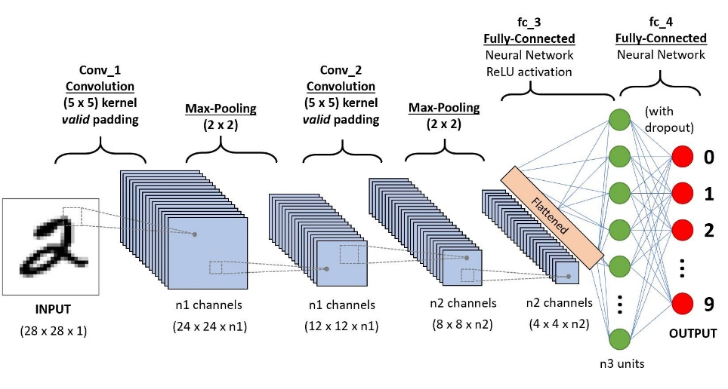

**1. Convolutional Layers**: CNNs consist of multiple convolutional layers. Each convolutional layer applies a set of learnable filters (kernels) to the input image. These filters slide across the input image, performing element-wise multiplication and summing operations (convolution operation). The result is a feature map that represents the presence of specific features or patterns at different spatial locations in the input image.

**2. Activation Function:** After each convolutional operation, an activation function (such as ReLU) is applied element-wise to introduce non-linearity into the network.

**3.Pooling Layers:** Pooling layers are used to downsample the feature maps obtained from the convolutional layers. Common pooling operations include max pooling and average pooling, which reduce the spatial dimensions of the feature maps while retaining important information.

**4. Fully Connected Layers (Dense Layers):** After several convolutional and pooling layers, one or more fully connected layers (also known as dense layers) are typically added at the end of the network. These layers connect every neuron in one layer to every neuron in the next layer, similar to a traditional feedforward neural network. The fully connected layers are responsible for combining the extracted features from the convolutional layers and making final predictions.

**5. Flattening:** Before passing the output of the last convolutional or pooling layer to the fully connected layers, the feature maps are flattened into a one-dimensional vector.

**Differences from a Fully Connected Neural Network (FCNN):**

A Convolutional Neural Network (CNN) architecture consists of convolutional layers, activation functions, pooling layers, and fully connected layers. CNNs are designed for processing grid-like data, such as images.

* **Local Connectivity:** CNNs have local connectivity, meaning neurons in each layer are connected to a small region of the input. This reduces the number of parameters compared to FCNNs**.**
* **Parameter Sharing:** CNNs share parameters across different regions of the input, making them more efficient in learning hierarchical features.
* **Translation Invariance:** CNNs are translation invariant, recognizing patterns regardless of their position in the input, achieved through convolutional and pooling operations.
* **Hierarchical Feature Learning:** CNNs learn hierarchical representations of features, capturing simple to complex features across layers, crucial for tasks like image recognition.

5. **What are the advantages of using convolutional layers in CNNs for image recognition tasks?**

**Ans:**

**Advantages:**

**Efficiency:** Sparse connectivity and parameter sharing reduce the number of parameters and computations, making CNNs more efficient.

**Translation Invariance:** Parameter sharing allows CNNs to recognize patterns regardless of their position in the image.

**Hierarchical Feature Learning:** CNNs learn hierarchical representations of features, capturing both simple and complex patterns.

**Localized Processing**: Convolutional layers process localized regions of the input, preserving spatial information effectively.

**GPU Parallelization:** CNNs with convolutional layers are highly parallelizable on GPUs, accelerating training and inference.

6. Explain the role of pooling layers in CNNs and how they help reduce the spatial dimensions of feature maps.

**Ans:** Pooling layers play a crucial role in Convolutional Neural Networks (CNNs) by reducing the spatial dimensions of feature maps while retaining important information. Here's how pooling layers work and how they help in dimensionality reduction:

1. **Pooling Operation:** The pooling operation is applied independently to each feature map (channel) of the input. It involves sliding a fixed-size window (pooling kernel) across the feature map and applying a pooling function to extract a single value that summarizes the information within the window.
2. **Spatial Down sampling:** Pooling layers perform spatial down sampling, reducing the spatial dimensions (width and height) of the feature maps while preserving their depth (number of channels). This downsampling helps in reducing the computational complexity of subsequent layers and prevents overfitting by introducing some degree of spatial invariance
3. **Pooling Functions:** Common pooling functions include:

* **Max Pooling:** Takes the maximum value within each pooling window. Max pooling is effective in capturing the most prominent features within each region of the feature maps.
* **Average Pooling:** Computes the average value within each pooling window. Average pooling provides a smoothed representation of the input, useful for reducing noise and emphasizing general trends.

1. **Reduction of Spatial Dimensions:** By applying pooling operations with appropriate parameters (e.g., window size and stride), the spatial dimensions of the feature maps are reduced. For example, applying a max pooling operation with a 2x2 window and a stride of 2 reduces the width and height of the feature map by half.
2. **Information Retention:** While reducing spatial dimensions, pooling layers aim to retain essential information by selecting the most salient features within each pooling window. Max pooling, in particular, selects the most active features, while average pooling provides a more generalized summary of the input.

**7. How does data augmentation help prevent overfitting in CNN models, and what are some common techniques used for data augmentation?**

**Ans:**

Data augmentation is a technique used to prevent overfitting in Convolutional Neural Network (CNN) models by artificially increasing the size of the training dataset through various transformations applied to the existing training samples. This helps the model generalize better to unseen data by exposing it to a wider variety of training examples. Here's how data augmentation helps prevent overfitting and some common techniques used:

**Preventing Overfitting:**

**1. Increased Dataset Size:** Data augmentation effectively increases the size of the training dataset by generating new samples from the existing ones. With a larger dataset, the model has more diverse examples to learn from, reducing the risk of overfitting to the limited training data.

**2. Regularization:** Introducing variations in the training data through augmentation acts as a form of regularization, discouraging the model from memorizing specific details of the training samples and instead learning more robust and generalized features.

**Common Data Augmentation Techniques:**

* **Horizontal Flipping:** Flipping images horizontally to create new samples. This is particularly useful for tasks where left-right orientation is not important, such as object recognition.
* **Rotation:** Rotating images by a certain angle (e.g., 90 degrees, 180 degrees) to introduce variations in orientation.
* **Scaling and Resizing:** Scaling images by zooming in or out, or resizing them to different dimensions. This helps the model learn to recognize objects at different scales and sizes.
* **Translation:** Shifting images horizontally or vertically within the frame. This simulates variations in object position and helps the model become invariant to small translations.
* **Brightness and Contrast Adjustment:** Changing the brightness, contrast, or saturation of images to simulate variations in lighting conditions.
* **Noise Injection**: Adding random noise to images to make the model more robust to noisy input.
* **Crop and Pad:** Randomly cropping or padding images to different sizes, simulating variations in framing and aspect ratio.
* **Color Jittering:** Randomly adjusting color channels (e.g., hue, saturation, brightness) to introduce variations in color appearance.

**8. Discuss the purpose of the flatten layer in a CNN and how it transforms the output of convolutional layers for input into fully connected layers.**

**Ans:**

The flatten layer in a Convolutional Neural Network (CNN) serves the purpose of reshaping the output of the preceding convolutional and pooling layers into a one-dimensional vector. This transformation is necessary to bridge the gap between the convolutional/pooling layers and the subsequent fully connected layers. Here's how the flatten layer works and its role in transforming the output of convolutional layers for input into fully connected layers:

**Purpose of the Flatten Layer:**

* **Transition to Fully Connected Layers:** In a CNN, convolutional and pooling layers are responsible for extracting features from input images while preserving spatial information. These layers produce feature maps with multiple channels and spatial dimensions.
* **Preparation for Dense Layers:** Fully connected layers (also known as dense layers) in a CNN require one-dimensional input vectors. However, the output of convolutional and pooling layers is typically multi-dimensional.
* **Flattening Process:** The flatten layer essentially collapses the multi-dimensional feature maps obtained from the convolutional and pooling layers into a single vector by stacking the values along a single dimension. This process converts the spatial information contained in the feature maps into a format suitable for processing by the fully connected layers.

**Transformation Process:**

* **Input from Convolutional/Pooling Layers:** The output of the last convolutional or pooling layer is typically a tensor with dimensions representing the number of samples, spatial dimensions (width, height), and number of channels (depth).
* **Flattening Operation:** The flatten layer reshapes this tensor into a one-dimensional vector by concatenating all the values along a single dimension. This operation removes the spatial structure of the feature maps while preserving the channel information.
* **Output for Fully Connected Layers:** The resulting one-dimensional vector serves as the input to the fully connected layers. Each element of this vector corresponds to a feature extracted from the input image by the convolutional and pooling layers.

**9. What are fully connected layers in a CNN, and why are they typically used in the final stages of a CNN architecture?**

**Ans:**

Fully connected layers, also called dense layers, are commonly used in the final stages of a CNN. They process extracted features globally, connecting every neuron to every neuron in the next layer. Unlike convolutional and pooling layers, which preserve spatial relationships, fully connected layers focus on global feature processing.

Here's why fully connected layers are typically used in the final stages of a CNN architecture:

* **Global Feature Aggregation:** After the convolutional and pooling layers have extracted spatial features from the input data, fully connected layers aggregate these features globally across the entire input. This allows the model to learn high-level representations by considering the relationships between all the features, regardless of their spatial positions.
* **Non-linear Mapping to Output Classes:** Fully connected layers are often followed by a softmax activation function, which converts the raw output of the network into probabilities across different output classes. This allows the CNN to make predictions by mapping the learned features to specific classes in the output space.
* **Classification and Decision Making:** In many CNN applications, such as image classification, object detection, and recognition, the final task involves making a decision or assigning a label to the input data based on the extracted features. Fully connected layers are well-suited for this task as they can learn complex decision boundaries and patterns in the feature space.
* **Parameter Adaptation:** The parameters (weights and biases) of fully connected layers are learned during training through backpropagation, allowing the model to adapt to the specific characteristics of the input data and the task at hand. This enables the CNN to optimize its performance and make accurate predictions on unseen data.

**10. Describe the concept of transfer learning and how pre-trained models are adapted for new tasks.**

**Ans:**

Transfer learning is a machine learning technique where a model trained on one task is repurposed or adapted for a different but related task. It leverages the knowledge learned from a source task to improve performance on a target task, particularly when the target task has limited training data.

Here's how transfer learning works and how pre-trained models are adapted for new tasks:

* **Pre-trained Models:** Pre-trained models are neural network architectures that have been trained on large datasets for a specific task, such as image classification or natural language processing. These models learn to extract useful features from the input data and make predictions based on these features.
* **Reuse of Feature Extractors:** In transfer learning, the lower layers of a pre-trained model, which capture general features like edges, textures, and shapes, are reused as feature extractors for the new task. These layers have learned to extract generic features from the input data, which can be valuable for a wide range of related tasks.
* **Fine-tuning:** After reusing the lower layers as feature extractors, the higher layers of the pre-trained model are adapted or fine-tuned to the specifics of the new task. This involves updating the weights of these layers using a smaller dataset specific to the target task. Fine-tuning allows the model to learn task-specific patterns and nuances while still benefiting from the knowledge learned from the source task.
* **Adjustment of Output Layers:** Depending on the nature of the target task, the output layers of the pre-trained model may need to be adjusted or replaced. For example, in image classification tasks, the output layer may need to be modified to accommodate the number of classes in the new dataset. In natural language processing tasks, the output layer may need to be adapted for a different set of labels or categories.
* **Regularization:** To prevent overfitting when fine-tuning the model on the new task, regularization techniques such as dropout or weight decay may be applied. These techniques help to generalize the model and improve its performance on unseen data.
* **Evaluation and Iteration:** Once the pre-trained model has been adapted for the new task, it is evaluated on a separate validation or test dataset to assess its performance. Depending on the results, further adjustments or iterations may be made to improve performance.

**11. Explain the architecture of the VGG-16 model and the significance of its depth and convolutional layers.**

The VGG-16 model is a convolutional neural network (CNN) architecture that was proposed by the Visual Geometry Group (VGG) at the University of Oxford. It is called VGG-16 because it consists of 16 layers, including 13 convolutional layers and 3 fully connected layers.

**Architecture:**

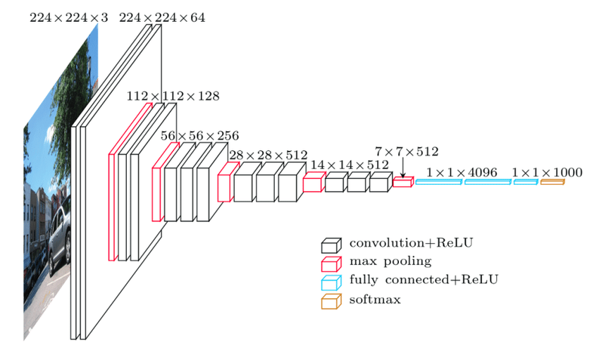

**1. Input Layer:** Accepts input images of fixed size (usually 224x224 pixels).

**2. Convolutional Layers (Conv Blocks):** The network contains 13 convolutional layers, each followed by a rectified linear unit (ReLU) activation function, which introduces non-linearity to the model. Each convolutional layer uses small receptive fields (3x3) with a stride of 1 and same padding. These convolutional layers learn various low to high-level features from the input images.

**3. Max Pooling Layers:** After every two convolutional blocks, there is a max-pooling layer with a 2x2 window and a stride of 2. Max pooling helps in downsampling the spatial dimensions, reducing the computational complexity and the number of parameters in the model while preserving the important features.

**4. Fully Connected Layers (FC Layers**): The final part of the network consists of three fully connected layers. The first two fully connected layers contain 4096 neurons each, followed by ReLU activation functions. The last fully connected layer contains 1000 neurons with a softmax activation function, producing the probabilities for each class in the output layer.

**The significance of VGG-16's depth and convolutional layers lies in several aspects:**

**1. Feature Learning:** The depth of VGG-16 allows it to learn a hierarchical representation of features from raw pixel values. The initial layers learn simple features like edges and textures, while deeper layers learn more complex and abstract features.

**2. Discriminative Power:** Deeper networks can capture more discriminative features, enabling better performance in tasks like object recognition, classification, and detection.

**3. Parameter Efficiency:** Despite its depth, VGG-16 has a relatively simple architecture with small convolutional filters (3x3). This design choice helps in parameter efficiency, allowing the model to learn a large number of filters with fewer parameters compared to models with larger filters.

**4. Transfer Learning:** The pre-trained weights of VGG-16 on large datasets like ImageNet can be used for transfer learning, where the knowledge learned from one task (e.g., ImageNet classification) can be transferred to a different but related task with limited labeled data. This makes VGG-16 a popular choice for various computer vision tasks**.**

**12. What are residual connections in a ResNet model, and how do they address the vanishing gradient problem?**

**Ans:**

Residual connections, also known as skip connections, are a key component of Residual Networks (ResNets), a type of deep neural network architecture. In traditional neural networks, each layer learns to transform its input into a slightly more abstract and complex representation. However, as the network gets deeper, it becomes increasingly difficult to train due to the vanishing gradient problem.

The vanishing gradient problem occurs when gradients become extremely small as they propagate backward through many layers during the training process. As a result, the weights of early layers receive negligible updates, and these layers may fail to learn meaningful features, hindering the overall performance of the network.

Residual connections address this problem by introducing shortcut connections that skip one or more layers. Instead of simply stacking layers one after another, the input to a layer is combined with the output of one or more preceding layers. Mathematically, the output of a residual block can be represented as:

* Output= input+F(input)

By including these shortcut connections, ResNets enable the network to learn residual functions, which essentially learn to fine-tune the identity mapping of the input. If the optimal transformation for a particular input is close to the identity mapping, the weights of the residual block can adjust to nearly zero, effectively bypassing the transformation. This flexibility allows ResNets to train much deeper networks without encountering the vanishing gradient problem.

**13. Discuss the advantages and disadvantages of using transfer learning with pre-trained models such as Inception and Xception.**

**Ans:**

**Advantages:**

1. **Feature Extraction:** Leveraging pre-trained models enables extraction of rich, generalized features from large datasets.
2. **Reduced Training Time:** Fine-tuning pre-trained models typically requires fewer training iterations, saving time and computational resources.
3. **Improved Generalization:** Transfer learning enhances model performance, especially with limited data, by leveraging learned features.
4. **Overfitting Mitigation:** Pre-trained models help in regularizing and mitigating overfitting, improving model generalization.
5. **Ease of Implementation:** APIs and frameworks facilitate straightforward implementation of transfer learning.

**Disadvantages:**

1. **Limited Adaptability:** Pre-trained models may not perfectly suit specific tasks or domains, requiring further fine-tuning.
2. **Domain Shift Challenges:** Significant dataset distribution differences can reduce the effectiveness of transfer learning.
3. **Resource Intensive:** Fine-tuning still demands substantial computational resources, particularly for large datasets and complex models.
4. **Model Complexity Concerns:** Large model sizes and complexity may pose challenges in memory and resource-constrained environments.

**14. How do you fine-tune a pre-trained model for a specific task, and what factors should be considered in the fine-tuning process?**

**Ans:**

Fine-tuning a pre-trained model for a specific task involves adapting the learned features of the model to perform well on a new dataset or task. Here's a general overview of the fine-tuning process and the factors to consider:

1. **Select a Pre-trained Model:** Choose a pre-trained model that is suitable for your task and dataset. Common choices include models like VGG, ResNet, Inception, Xception, etc., depending on the nature of your data and the complexity of the task.
2. **Remove Last Fully Connected Layers:** Since the final fully connected layers of pre-trained models are typically specific to the original task (e.g., ImageNet classification), remove these layers. Retaining the convolutional layers ensures that the model retains its ability to extract relevant features.
3. **Add New Fully Connected Layers:** Add new fully connected layers at the end of the network. The number of neurons in the final layer should match the number of classes in your dataset, and the activation function can be chosen based on the nature of your task (e.g., softmax for classification).
4. **Fine-tune the Model:** Train the modified model on your dataset using techniques such as stochastic gradient descent (SGD), Adam, or other optimization algorithms. Monitor the training process by observing metrics such as loss and accuracy on both training and validation sets.
5. **Regularization:** Apply regularization techniques such as dropout or weight decay to prevent overfitting during fine-tuning. These techniques help generalize the model to unseen data and improve its performance.
6. **Learning Rate Scheduling:** Experiment with different learning rate schedules to find the optimal learning rate for your fine-tuning process. Techniques such as learning rate decay or cyclical learning rates can help converge to better solutions faster.
7. **Evaluation and Validation:** Evaluate the fine-tuned model on a separate validation set to assess its performance. Fine-tune hyperparameters as needed based on validation performance.
8. **Test on Unseen Data:** Finally, test the fine-tuned model on a hold-out test set or real-world data to assess its performance in a real-world scenario.

**Factors to consider in the fine-tuning process:**

* **Dataset Size:** The size of your dataset influences the extent to which you can fine-tune the model. Larger datasets may allow for more extensive fine-tuning, while smaller datasets may require more regularization and careful tuning of hyperparameters.
* **Task Complexity:** The complexity of your task and the similarity to the pre-trained task affect how much fine-tuning is necessary. More complex tasks may require more extensive fine-tuning and architectural modifications.
* **Computational Resources:** Fine-tuning deep neural networks can be computationally intensive, so consider the availability of computational resources when planning the fine-tuning process.
* **Overfitting:** Regularization techniques are essential to prevent overfitting during fine-tuning, especially when dealing with small datasets or complex models.
* **Transfer Learning Strategy:** Decide whether to freeze some or all of the pre-trained layers based on the similarity between the pre-trained task and your task, as well as the size of your dataset.

**15. Describe the evaluation metrics commonly used to assess the performance of CNN models, including accuracy, precision, recall, and F1 score.**

**Ans:**

Evaluation metrics are essential for assessing the performance of Convolutional Neural Network (CNN) models. Here are the commonly used evaluation metrics:

**1.** **Accuracy:** Accuracy is the most straightforward metric and measures the overall correctness of the model's predictions. It is calculated as the ratio of correctly predicted samples to the total number of samples:

* Accuracy= number of correct predictions/total no of predictions.

**2.** **Precision**: Precision measures the proportion of correctly predicted positive cases out of all predicted positive cases. It focuses on the accuracy of positive predictions and helps evaluate the model's ability to minimize false positives.

* Precision= True positives/(true positives+ false positives)

**3. Recall (Sensitivity):** Recall, also known as sensitivity or true positive rate, measures the proportion of correctly predicted positive cases out of all actual positive cases. It focuses on the ability of the model to capture all positive instances and avoid false negatives.

* Recall= True positives/(true positives+ false negatives)

**4. F1 Score:** The F1 score is the harmonic mean of precision and recall, providing a balanced measure of a model's performance. It considers both false positives and false negatives and is particularly useful when the class distribution is imbalanced.

* F1 Score= 2 * (precison x recall)/ * (precison + recall)

5.**Specificity:** Specificity measures the proportion of correctly predicted negative cases out of all actual negative cases. It complements recall and focuses on the model's ability to avoid false alarms in negative instances.

* Specificity = True Negatives /(True Negatives +False Positives)

**6.ROC Curve and AUC:** Receiver Operating Characteristic (ROC) curve is a graphical plot that illustrates the performance of a binary classifier across different threshold settings. The Area Under the Curve (AUC) summarizes the ROC curve's performance in a single value, representing the classifier's ability to distinguish between positive and negative classes across all thresholds.